NGACN browser for Android
Latest update: 2/13/2012 by SongZhi Zhao | Author: FengRong Shi
Contents
1. Goal 2
2. Requirement specific 2
3. System Functional Specific 4

Goal
To develop a convenient android APP to browse the NGACN website, reduce the mobile flow rate, and include most function in NGACN site.

Requirement specific
Name | Description |  | State
Index | Show the NGACN index. Long click the blank or one tag, will show add new tag. Menu button will show some help list of all the ID of area. | Pending |  | 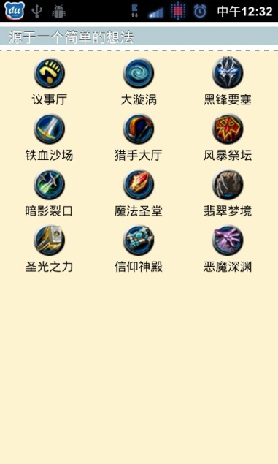
Logon | Logon the NGACN with username and password, and show the user log on successfully. Show the basic information (such like name) of the current user in a clear place. Make the app could remember the information of user who don`t need to input the username and password again when they login next time. | Pending |  | 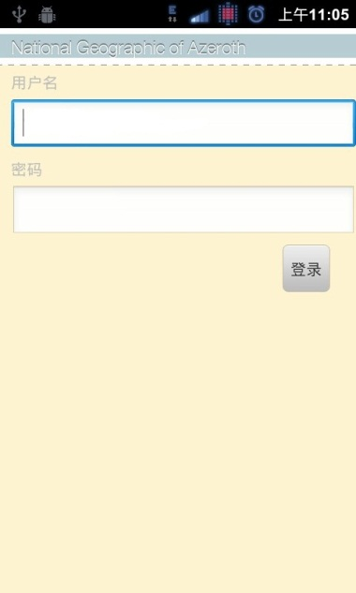
View thread list | Show the thread list, and top thread. The thread information includes title; author; how many reply; latest reply time. Differ the thread title with color, such like blue(official),red (important), green (hint). | Pending |  | 
View single thread | Show the thread topic on the top of the list. Show every single reply, author and reply time. Provide configuration to whether show the signature, thumb image or not. Include the Wow gear signature. | Pending |  |   How about we try this UI  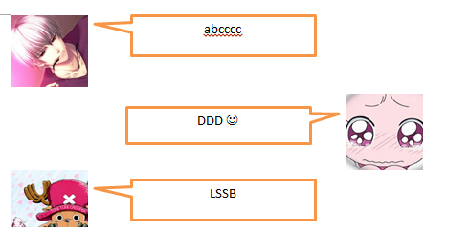
Thread Navigator | Provide user a quick navigator to switch areas. the target could be a collected thread or an area. | Pending |  | 
Reply and quote | The replay could edit the Icon image, define the topic classification, insert the emoticons and insert the BBS code. Quote some text, should take a brief message to show.  (Modify the font, update the pic, watermark and inserting can be added next generation) | Pending |  | 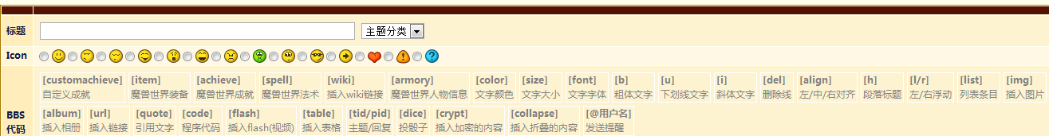
Thread operation | Mark the thread should be a quick operation (Click the author could link to the web, but we can`t zip the flow rate of the target web) | Pending |  | 
Create a new thread | The same as Reply | Pending
Reduce the flow rate | Some way must be there to cut the mobile flow rate. Currently, the web style, font information, picture takes most of them. We cut them. External links warning window should be functional too. | Pending
Mode change for WIFI/3G and 2G | I think use two kind of configuration, and an advanced menu for user to customize is a good way. | Pending
Common operation | Log out, clear cache, feedback help. | Pending

System Functional Specific

